Here I develop a bike showroom console application using java and json file. They are basically used to see the bike data based on user selection. In future I add some more features, which are all explained below.

**WORK FLOW DIAGRAM:**

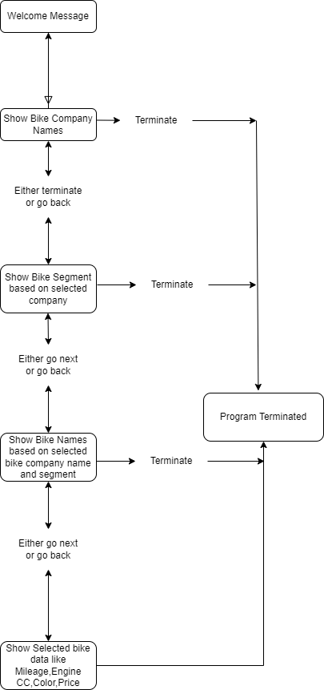

**Class Details**

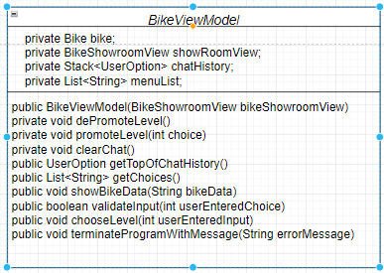

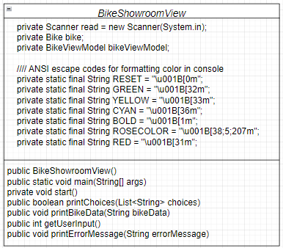

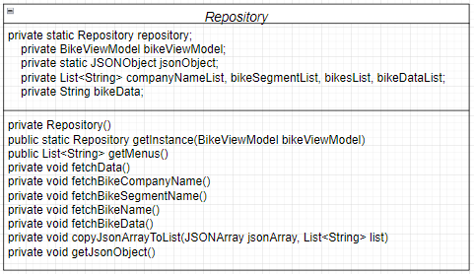

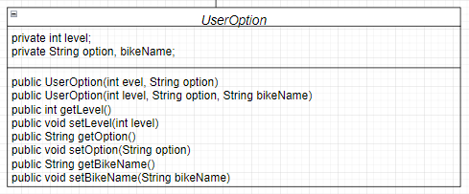

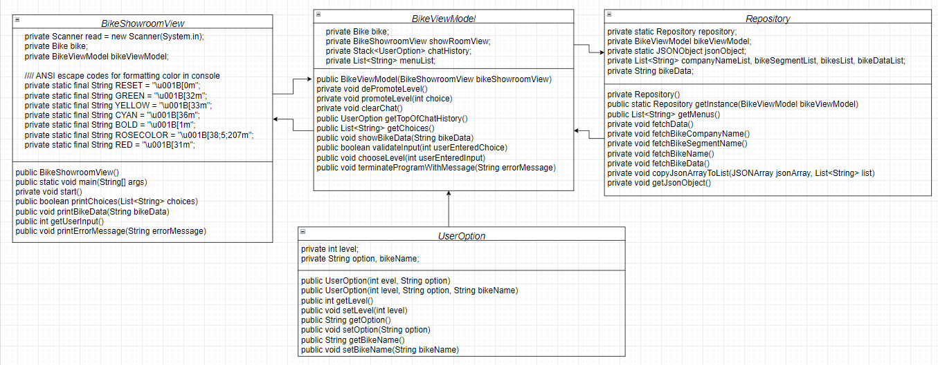

**Upcoming Release :**

* Add Bike
* Remove Bike
* Update Bike
* Bike Bill
* Bike Stock Maintains
* Customer Data Maintains/